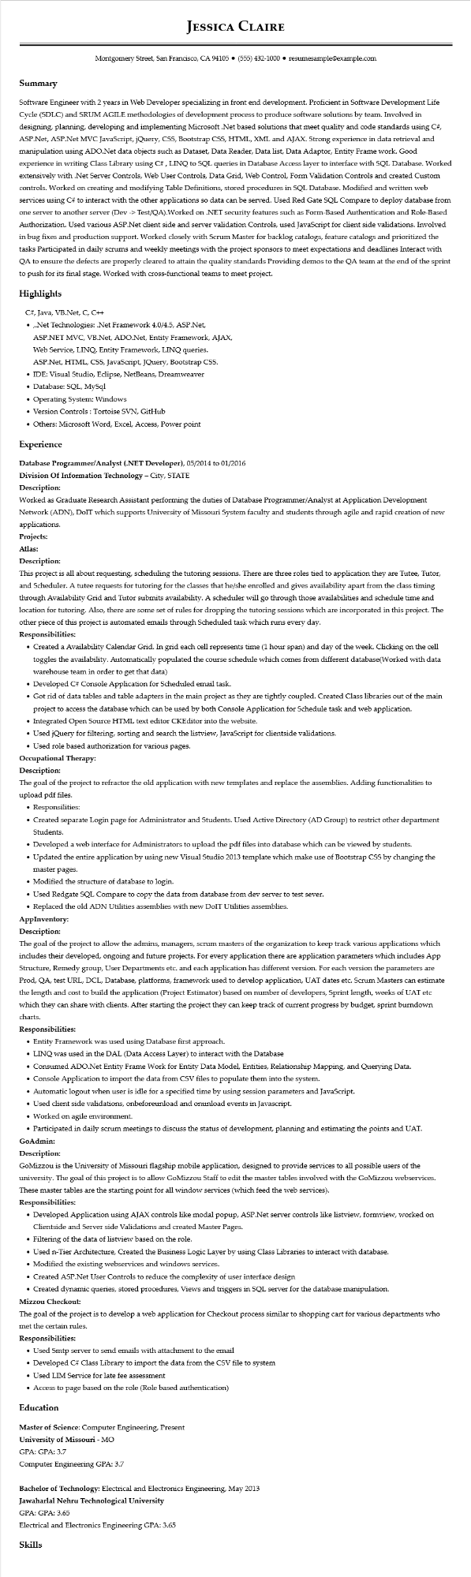
JESSICA CLAIRE
Montgomery Street, San Francisco, CA 94105 ⚫ (555) 432-1000⚫ resumesample@example.com
Summary
Software Engineer with 2 years in Web Developer specializing in front end development. Proficient in Software Development Life Cycle (SDLC) and SRUM AGILE methodologies of development process to produce software solutions by team. Involved in designing, planning, developing and implementing Microsoft .Net based solutions that meet quality and code standards using C#, ASP.Net, ASP.Net MVC JavaScript, jQuery, CSS, Bootstrap CSS, HTML, XML and AJAX. Strong experience in data retrieval and manipulation using ADO.Net data objects such as Dataset, Data Reader, Data list, Data Adaptor, Entity Frame work. Good experience in writing Class Library using C#, LINQ to SQL queries in Database Access layer to interface with SQL Database. Worked extensively with .Net Server Controls, Web User Controls, Data Grid, Web Control, Form Validation Controls and created Custom controls. Worked on creating and modifying Table Definitions, stored procedures in SQL Database. Modified and written web services using C# to interact with the other applications so data can be served. Used Red Gate SQL Compare to deploy database from one server to another server (Dev -> Test/QA).Worked on .NET security features such as Form-Based Authentication and Role-Based Authorization. Used various ASP.Net client side and server validation Controls, used JavaScript for client side validations. Involved in bug fixes and production support. Worked closely with Scrum Master for backlog catalogs, feature catalogs and prioritized the tasks Participated in daily scrums and weekly meetings with the project sponsors to meet expectations and deadlines Interact with QA to ensure the defects are properly cleared to attain the quality standards Providing demos to the QA team at the end of the sprint to push for its final stage. Worked with cross-functional teams to meet project.
Highlights
C#, Java, VB.Net, C, C++
•,.Net Technologies: .Net Framework 4.0/4.5, ASP.Net,
ASP.NET MVC, VB.Net, ADO.Net, Entity Framework, AJAX,
Web Service, LINQ, Entity Framework, LINQ queries.
ASP.Net, HTML, CSS, JavaScript, JQuery, Bootstrap CSS.
• IDE: Visual Studio, Eclipse, NetBeans, Dreamweaver
• Database: SQL, MySql
• Operating System: Windows
• Version Controls: Tortoise SVN, GitHub
• Others: Microsoft Word, Excel, Access, Power point
Experience
Database Programmer/Analyst (.NET Developer), 05/2014 to 01/2016
Division Of Information Technology - City, STATE
Description:
Worked as Graduate Research Assistant performing the duties of Database Programmer/Analyst at Application Development Network (ADN), DoIT which supports University of Missouri System faculty and students through agile and rapid creation of new applications.
Projects: Atlas:
Description:
This project is all about requesting, scheduling the tutoring sessions. There are three roles tied to application they are Tutee, Tutor, and Scheduler. A tutee requests for tutoring for the classes that he/she enrolled and gives availability apart from the class timing through Availability Grid and Tutor submits availability. A scheduler will go through those availabilities and schedule time and location for tutoring. Also, there are some set of rules for dropping the tutoring sessions which are incorporated in this project. The other piece of this project is automated emails through Scheduled task which runs every day. Responsibilities:
• Created a Availability Calendar Grid. In grid each cell represents time (1 hour span) and day of the week. Clicking on the cell toggles the availability. Automatically populated the course schedule which comes from different database(Worked with data warehouse team in order to get that data)
• Developed C# Console Application for Scheduled email task.
• Got rid of data tables and table adapters in the main project as they are tightly coupled. Created Class libraries out of the main project to access the database which can be used by both Console Application for Schedule task and web application.
• Integrated Open Source HTML text editor CKEditor into the website.
• Used jQuery for filtering, sorting and search the listview, JavaScript for clientside validations.
• Used role based authorization for various pages.
Occupational Therapy:
Description:
The goal of the project to refractor the old application with new templates and replace the assemblies. Adding functionalities to upload pdf files.
• Responsilities:
• Created separate Login page for Administrator and Students. Used Active Directory (AD Group) to restrict other department Students.
• Developed a web interface for Administrators to upload the pdf files into database which can be viewed by students.
• Updated the entire application by using new Visual Studio 2013 template which make use of Bootstrap CSS by changing the master pages.
• Modified the structure of database to login.
• Used Redgate SQL Compare to copy the data from database from dev server to test sever.
• Replaced the old ADN Utilities assemblies with new DoIT Utilities assemblies.
AppInventory:
Description:
The goal of the project to allow the admins, managers, scrum masters of the organization to keep track various applications which includes their developed, ongoing and future projects. For every application there are application parameters which includes App Structure, Remedy group, User Departments etc. and each application has different version. For each version the parameters are Prod, QA, test URL, DCL, Database, platforms, framework used to develop application, UAT dates etc. Scrum Masters can estimate the length and cost to build the application (Project Estimator) based on number of developers, Sprint length, weeks of UAT etc which they can share with clients. After starting the project they can keep track of current progress by budget, sprint burndown charts.
Responsibilities:
• Entity Framework was used using Database first approach.
• LINQ was used in the DAL (Data Access Layer) to interact with the Database
• Consumed ADO.Net Entity Frame Work for Entity Data Model, Entities, Relationship Mapping, and Querying Data.
• Console Application to import the data from CSV files to populate them into the system.
• Automatic logout when user is idle for a specified time by using session parameters and JavaScript.
• Used client side validations, onbeforeunload and onunload events in Javascript.
• Worked on agile environment.
• Participated in daily scrum meetings to discuss the status of development, planning and estimating the points and UAT. GoAdmin:
Description:
GoMizzou is the University of Missouri flagship mobile application, designed to provide services to all possible users of the university. The goal of this project is to allow GoMizzou Staff to edit the master tables involved with the GoMizzou webservices. These master tables are the starting point for all window services (which feed the web services).
Responsibilities:
• Developed Application using AJAX controls like modal popup, ASP.Net server controls like listview, formview, worked on Clientside and Server side Validations and created Master Pages.
• Filtering of the data of listview based on the role.
• Used n-Tier Architecture, Created the Business Logic Layer by using Class Libraries to interact with database.
• Modified the existing webservices and windows services.
• Created ASP.Net User Controls to reduce the complexity of user interface design
• Created dynamic queries, stored procedures, Views and triggers in SQL server for the database manipulation.
Mizzou Checkout:
The goal of the project is to develop a web application for Checkout process similar to shopping cart for various departments who met the certain rules.
Responsibilities:
• Used Smtp server to send emails with attachment to the email
• Developed C# Class Library to import the data from the CSV file to system
• Used LIM Service for late fee assessment
• Access to page based on the role (Role based authentication)
Education
Master of Science: Computer Engineering, Present
University of Missouri - MO
GPA: GPA: 3.7
Computer Engineering GPA: 3.7
Bachelor of Technology: Electrical and Electronics Engineering, May 2013
Jawaharlal Nehru Technological University
GPA: GPA: 3.65
Electrical and Electronics Engineering GPA: 3.65
Skills

